The Patriarchal History:
Gen. 12 – 24 “The History of Israel’s Patriarch – Our Father in Faith”

The Covenant that God establishes with Abraham, which is passed down to his heirs Issac and Jacob and ultimately to the twelve tribes, becomes the foundation for the plan of salvation for mankind throughout the rest of biblical history.

N.B. – Toledoths (Generations) and Announcements of Death and Birth are literary markers of transition in the story.

*Chiastic Structure/Pattern often used in Scripture (O.T. and Gospels) – Chiasm – a reversal in the order of words/themes in two otherwise parallel phrases/structure.
Simple Ex. – “The sabbath was made for man, not man for the sabbath”.
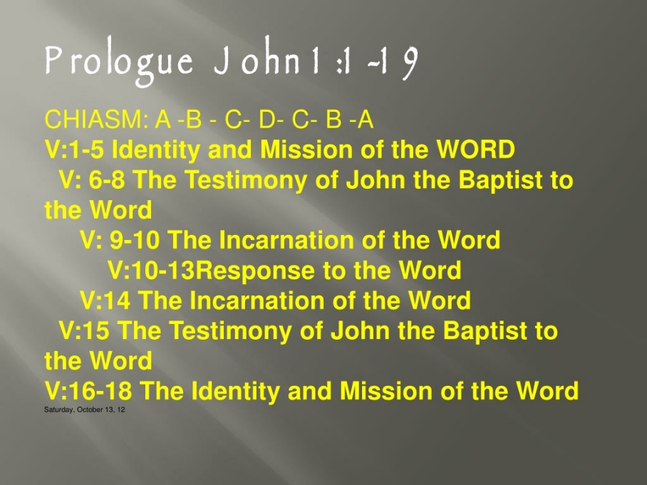
Used to Highlight Meaning/ a point about a passage:

What happened at the end of Primeval History?
- Growth of Human Sin after re-creation
- Biblical Narrative again focuses on one family line (Shem) and then one particular Man (Abram)
God’s Call/Promises to Abram (Gen. 12: 1-3):
- Great Nation: “I will make of you a great Nation”
- Great Name: “I will make your name great”
- Great/Universal Blessing: “By you all the families of the earth shall be blessed”

Notice – God’s initiative, not Abram’s (God saves/blesses not Man) – anti-Pelagianism sentiment.

God’s promises become solemn covenants.
The Great Nation: the sacrifice of the animals (Gen. 15)
The Great Name: the circumcision of Abraham (Gen. 17)
The Universal Blessing: the sacrifice of Issac (Gen. 22)

Importance of the figure Lot:
Lot (Abraham’s nephew and apparent heir) is a symbol of fallen man – not wholly evil (Lot shows hospitality to the Angels in Gen. 19) – however, Lot is flawed and plagued by selfishness, sloth, and intemperance and ultimately becomes the unwitting father of Israel’s hostile rivals and enemies, the Ammonites, and the Moabites.

Lot draws Abraham into danger because of his fallenness. Abraham nonetheless sought to be loyal to Lot and intervene for his welfare. (Image of God’s care for us even though we are sinners).

The Blessing of Melchizedek acts as a foreword to the Blessings God begins to reveal to Abram in Gen. 15.

Abram belief but then unbelief – Believes God’s declaration regarding descendants as numerous as the stars of the sky… “And he believed the Lord” (Gen. 15:6). However, Abram immediately doubts God’s further promise of possession of land – “O Lord God, how am I to know that I shall possess it?” (Gen. 15:8).

A weird sacrifice in Genesis 15 (Split animal carcasses)–
Ancient Mesopotamian way of ratifying a covenant, so as to say, “If I do not keep my commitments, may I be slain like these animals.”
By means of Animal sacrifice a solemn covenant is formed.

Promise of the Great Name (kingship) and the Covenant of Circumcision (Gen. 17)
Context of this Covenant – in Genesis 16, Abram and Sarai attempt to hasten God’s fulfillment of descendants through their own power, by means of an ancient reproductive technology – Surrogacy.

Surrogacy was a well-attested ancient Near Eastern practice of using servant women as surrogate mothers.

Sarai gives Hagar to Abram as a secondary wife and Hagar bears Ishmael.

“Abram listened to the voice of Sarai” …. / “Adam – because you have listened to the voice of your wife, and have eaten of the tree…”

Two covenant mediators that do not listen to the promises of God, but the advice of their spouse.

Polygamous relationships have already been shown to be problematic in Genesis 4 (Lamech – descendant of Cain) and these relationships lead to short and long term familial strife. (Ishmael and Hagar banished from the family at the behest of Sarah).
Ishmael and his people become antagonists and persecutors of Israel (Ishmael settles in Mecca and is regarded as the ancient root of Islam).

God makes it clear to Abram that Sarah will bear him a son, through whom the blessings/promises of God will be fulfilled – Abram laughs at God because of Sarai’s Old Age. Abram proposes Ishmael as the proper inheritor of the blessing, but God rejects it.

Divine Name Change – Abram to Abraham
Abram – “Exalted Father”
Abraham – “Father of a Multitude”

Sarai – “Princess”
Sarah – Mother of Nations (By way of Laughter)”

Issac – “He will laugh – Laughter”

Abraham will be remembered as a King of his Descendants, God promises a royal lineage (Fulfilled in David, Solomon, and later Jesus).

Assurance of the Covenant comes through a sacrificial sign – (Pre-Sacrament)
As Isaac, so their children were circumcised on the eighth day, according to the law: “An infant of eight days old shall be circumcised among you, every man child in your generations: he that is born in the house, as well as the bought servant shall be circumcised, and whosoever is not of your stock: And my covenant shall be in your flesh for a perpetual covenant. The male, whose flesh of his foreskin shall not be circumcised, that soul shall be destroyed out of his people: because he hath broken my covenant.”

Circumcision -
Spiritual and Practical
The Angelic Doctor gives three reasons why the organ of generation rather than any other was to be circumcised: (a) Abraham was to be blessed in his seed; (b) The rite was to take away original sin, which comes by generation; (c) It was to restrain concupiscence, which is found especially in the generative organs.

Health

Royalty – a sign of leisure and not slavery. One must rest after such a procedure.

Sign of Maturation/Ancient Initiation Rite – Ishamel being 13 years old

Circumcision is not only a sacrificial sign, but also a penitential act. Abram sinned by taking matters into his own hands by means of his sexual powers. Now God reminds his descendants that he is the one who accomplishes his promises, not us by deviating from God’s will and forcing our own will.

Ishamel remains a beneficiary of the first covenant (Genesis 15), and thus, he will have a great nation and be granted princes, but not kings. The Fatherhood of many nations is restricted to Issac and his line.

The Three Angels in Genesis 18
- Abraham a great man himself calls these men, Lord…
- “The Lord said, “I will surely return to you in the spring, and Sarah your wife shall have a son.” And Sarah was listening at the tent door behind him. 11 Now Abraham and Sarah were old, advanced in age; it had ceased to be with Sarah after the manner of women. 12 So Sarah laughed to herself, saying, “After I have grown old, and my husband is old, shall I have pleasure?” 13 The Lord said to Abraham, “Why did Sarah laugh, and say, ‘Shall I indeed bear a child, now that I am old?’ 14 Is anything too hard for the Lord? At the appointed time I will return to you, in the spring, and Sarah shall have a son.” 15 But Sarah denied, saying, “I did not laugh”; for she was afraid. He said, “No, but you did laugh.”

- Sign of the Trinity

- Talmud believed the angels to be - Michael, Gabriel, and Raphael. Michael came to tell that Sarah will give birth to a son; Raphael came to heal Abraham after his circumcision; and Gabriel came to destroy Sodom.

- Angels as Past, Present, and Future

Gabriel punishes for past sins (Maybe why he told Mary to not be Afraid), Raphael comes to heal in the present, and Michael foretells what will be in the Future (Michael the angel of the end times)

Sodom and Gomorrah
What is the sin of Sodom and Gomorrah?
- Hospitality?
- Social Injustice?
- Sexual Nature?

The men of the city demand that Lot, bring his guests to them, so that they may “know” them. – “know” is an ancient Hebrew euphemism for sexual relations.

Lot instead offers his daughters who did not yet know man… what a great father!

Archaeological proof of Sodom and Gomorrah – a site in modern day Jordan shows two extremely powerful and wealthy cities that were destroyed by a natural disaster. It seems that there was a fiery demise of these cities near the Dead Sea that has archaeologists at odds. In a layer of ancient earth, archaeologists claim to have found evidence of an apocalyptic event: Melted rooftops. Disintegrated pottery. Unusual patterns in the rock formations that can be associated with intense heat.

Abraham pleads to save Sodom and Gomorrah in case there are righteous people there – “if only 10” – shows the boldness of Abraham as a Patriarch, but mediator of the covenant with God

Blindness and sexual sin – disordered desires that blind the natural good – the men are struck blind at the door of Lot.

“When morning dawned, the angels urged Lot, saying, “Arise, take your wife and your two daughters who are here, lest you be consumed in the punishment of the city.” 16 But he lingered; so the men seized him and his wife and his two daughters by the hand, the Lord being merciful to him, and they brought him forth and set him outside the city. 17 And when they had brought them forth, they said, “Flee for your life; do not look back or stop anywhere in the valley; flee to the hills, lest you be consumed.” 18 And Lot said to them, “Oh, no, my lords; 19 behold, your servant has found favor in your sight, and you have shown me great kindness in saving my life; but I cannot flee to the hills, lest the disaster overtake me, and I die. 20 Behold, yonder city is near enough to flee to, and it is a little one. Let me escape there—is it not a little one?—and my life will be saved!” 21 He said to him, “Behold, I grant you this favor also, that I will not overthrow the city of which you have spoken. 22 Make haste, escape there; for I can do nothing till you arrive there” …
Then the Lord rained on Sodom and Gomor′rah brimstone and fire from the Lord out of heaven; 25 and he overthrew those cities, and all the valley, and all the inhabitants of the cities, and what grew on the ground. 26 But Lot’s wife behind him looked back, and she became a pillar of salt.

The Shameful Origin of Moab and Ammon – the incest of the daughters of Lot
- Drinking wine, similar to the shameful sons of Noah (Sin persists)

Universal Blessing and the Sacrifice of Issac (Genesis 22)

Aqedah – “the Binding of Issac” – Calvary of the Old Testament

Christians often call this the Sacrifice of Issac, but it is important to remember that Issac is bound but not slain.

The removal of all potential back-up heirs and the drama surrounding the long-awaited birth of Issac contribute to the heart-rending intensity Abraham undergoes.

“your only son, whom you love” offer him as a “burnt offering (whole and entire)” upon a mountain chosen by God

Increasing seriousness of the covenant:
1. Taken from the Flock of Abram
2. Taken from Abram’s own flesh
3. Taken from Abraham’s most beloved possession – His only Begotten Son

Abraham must offer what is most dear to him to God – nothing can be held back – kenosis – kenotic love – self emptying.

Kenosis and Creation – God creates because of his Nature which is self-emptying love.

Some points of Interest:

Issac and Jesus as the only, begotten son

Issac is not a small child as some artists depict, he is a full grown man and could easily overpower his Father – i.e. Issac willing goes with Abraham and does not voice an objection. Also, Issac carries a large/sufficient amount of wood up a mountain for a burnt offering.

God never actually intends for Issac to be put to death – this is an unveiling of Abraham’s utter faith, which God has been trying to teach him. Abraham much like the beginning of his call is told to travel from home to follow the will of God, so he travels 3 days to Mt. Moriah

Mount Moriah is not just some mountain, it is the place where the house of the Lord in Jerusalem (the Temple) will be built (2 Chronicles 3:1). Where Issac is to be sacrificed will be the place of future covenant blessings. “So, Abraham called the name of that place “The Lord will provide,” as it is said to this day, “On the mount of the Lord it shall be provided.”

In some streams of Jewish tradition, sacrifices at the Temple were regarded as memorials/re-presentations of the Sacrifice of Issac, the rationale being that the blood of bulls and goats was not effective in itself but symbolized the truly meritorious self-offering of the forefather of the entire nation.

Abraham implicitly believes in the Resurrection.

There is a change in the covenant – God purely grants the blessing… “by myself I have sworn… I will indeed bless you”

Vassal Covenant – imposed by superior party on lesser party to control the behavior of the lesser party

Parity Covenant – emphasizes mutuality and familial relationship

Grant Covenant – only the superior party swears, a unilateral promise of benefit from the superior to the inferior, usually as a reward for notable fidelity

The promises to Abraham are no longer dependent on the weakness of human performance but solely on divine commitment – a sign of hope and mercy.

In Genesis 23, Abraham purchases a burial plot for his wife Sarah from Ephron the Hittite. This is significant because it is the first property of the chosen race in the promised land. The purchase of the field is also noteworthy because it is interwoven with the sacred narrative of the ways of God with man 1. Abraham’s purchase of the land is a sign of his confidence in the Lord’s blessing. By purchasing a prominent burial plot, the Cave of Machpelah, Abraham anchors the future Jewish people’s claim to the land 3. His being buried there “at a ripe old age,” and his children and grandchildren being buried alongside him, would provide irrefutable proof to their descendants of their deep historic roots in the land.

Issac and Rebekah
Abraham’s last mission to get his heir married – continue the generational line

There is a consistent symbolism surrounding women at wells in the Bible. This is the image of a bride-to-be and can therefore represent the Church awaiting the day of Christ's return. Many of the great men of the Bible met their future wives at wells - Issac and Rebekah, Jacob and Rachel, Moses and Zipporah.

Issac and Rebekah’s marriage as a loving one and no direct evidence that Issac had any other wives.

Ending Notes:
Abraham as image of personal relationship with God and not saved through legalism.
Identity of Melchizedek – Abram pays homage.

Looking Forward –
Jacob Cycle and Joseph Cycle: Stories of Brotherly Rivalry and Human Reconciliation (Gen. 25-50)

Next Meeting – February 14th at 5pm – The Annunciation Center at St. Cyril and Methodius Parish, Fairchance

