The Book of Leviticus – “pertaining to the Levites”
- Concerned with the cultic regulations for the Levitical priests, such as the laws of sacrifice (Lev 1-7) and the laws regarding the ordination of priests (8-10).
- However, the majority of passages in Leviticus actually address the Israelite people, such as Laws of Purity (11-16), holiness (17-26), and vows (27).

Who are the Levites – history of Genesis and Exodus?

The Book of Leviticus stands at the very heart of the Pentateuch. In modern time, Leviticus is a book used in teaching contemporary orthodox, Jewish boys about cleanliness and holiness as the basis for religious adherence.

The concepts of priesthood, sacrifice, cleanliness, and holiness embodied in Leviticus establish the context in which Jesus – as an adherent Jew – would have lived in and ultimately fulfilled in Himself. Thus, the Church has always studied Leviticus to see the foreshadowing of the Messiah.

Leviticus has the least historical narrative in the books of the Pentateuch – thus it can be difficult to read. There are only two narrative accounts, that of the ordination of Aaron and his sons (Lev 8-10), and the account of the blasphemer and his punishment and stoning (Lev 24:10-23).

Everything else in Leviticus is laws and regulations and one chapter (Lev 26) with blessings and curses.

Leviticus mostly recounts God’s direct speeches to Moses coming from the Tabernacle at Mt. Sinai, which occurs before the Israelites set out on their journey across the desert to the Promised Land (see Num 1-25).

Remember, the book of Exodus ended with the erection and construction of the Tabernacle, and thus it makes sense that Leviticus opens with God calling to Moses from the newly erected sanctuary.

God speaks to Moses from the Tabernacle – The Tabernacle has replaced Mt. Sinai
- God will go with His people and be present to them, in their midst – Portable Sinai – New Eden
- A foreshadowing of Incarnation – God being among?

Basic Meaning of All Sacrifice (grain/vegetable, drink, animal) is self-offering. Symbolically, the worshipper offers himself to God.

Qorban vs Zebah – offering vs sacrifice.
Sacrifices need to be transformed through slaughter where offerings are just given up.

1st Major Section of Leviticus (1-7) talks about types of Sacrifice
3 Types of Sacrifice know before Leviticus:
- Burnt – Hebrew - ‘olah = “ascending,” smoke going up; Greek - holocaust = “burnt whole,” a complete consumption of the sacrifice. The burnt offering was never eaten everything is given up to God. Offeror lays hands on head of animal as a sign of transferring identity by symbolic representation.

- Grain – Hebrew – Minhah = “gift or tribute,” some translate as a cereal offering, a form of cake baked or not. Communion with God through a meal – only a portion was burnt and the rest was consumed by the priests.

- Peace – Hebrew – shelamin = “peace, wholeness,” the fat of the animal was considered a delicacy and was offered to God, but priest and people ate the rest of the animal in a celebratory feast together with the grain offering than accompanied it. Because the peace offering was a communal meal with God and his servants (the priests), it always followed any other offerings (burnt, sin, or guilt). While the sin and guilt offerings serve to restore peace or shalom with God, the peace offering both recognizes and celebrates it. It is a sacrifice of joy and thanksgiving.

These express communion with God. These were offered before the Tabernacle and continue to be offered on free standing altars apart from the Tabernacle late into Israel’s history.

2 Types Leviticus introduces particular to the Tabernacle:
- Sin – Hebrew – hattat – “sin” – this sacrifice de-sins someone through forgiveness, it restores communion and purifies a person or an object. This sin offering restores ritual cleanness which may have been lost by unwitting moral or ritual violations.
- Guilt – Hebrew – asham – “trespass” – debate of scholars on how it differs from a sin offering. Most likely, the sin offering restores the relationship with God and the offeror through forgiveness, the guilt offering makes reparation or restitution for the damage done by sin. In other words, sin has a kind of double consequence: forgiveness and reparation are not the same thing, and the two kinds of sacrifice are meant to deal with each of them respectively.

These express restoration of communion with God. These sacrifices are only present after the Tabernacle’s erection and were specific to the worship at the Tabernacle and in the Temple.

Sacrifices in Leviticus require a priest to officiate, so naturally the account of the inauguration of the Priesthood follows (Lev 8-10)
The last element that needs to be installed in the Tabernacle system is the priesthood itself. Intriguingly, Moses serves as a kind of “supreme” priest and prophet performing sacrifice and actions necessary to ordain Aaron and his sons to the post-Golden Calf Levitical priesthood.
Steps of Ordination:
- Washing with water (Lev 8:5-6)
- Vesting of Aaron, the high priest (Lev 8:7-9)
- Anointing with oil of priests, Tabernacle, altar and utensils (Lev 8:10-14)
- Vesting of Aaron’s sons as priest (Lev 8:10-13)
- Ordination sacrifices (Lev 8:14-31)
- Ordination banquet of “flesh and bread” (Lev 8:31-35)

English translation = “ordain”
Hebrew literal expression = “fill your hand(s)” – the priest’s hands are consecrated to offer sacrifice, as Leviticus itself states when it says of the priest: “And he presented the cereal offering, and filling his hand from it, and burned it upon the altar” (Lev 9:17; cf. 2:2). By filling his hand the priest offers his first sacrifice.

You better be a good priest!!!
Aaron vs his Sons

Holy vs unholy fire
- Nadab and Abihu’s deaths show the severity of the power and responsibility of the Levitical Priesthood
- Thus, priests are to be set apart, to act in a holy and serious way. Priests are to avoid “wine” and “strong drink” (Lev 10:9) while ministering and have the privilege and duty of teaching the people the difference between “the holy and the common, and between the unclean and the clean” (Lev 10:10). The priests are described as sin-bearers, who are not only to consume the celebratory peace offerings but even the flesh of the “sin offering”, so that they might “bear the iniquity of the congregation, to make atonement for them before the Lord” (Lev 10:17).
The “Cleanliness Code” (Lev 11-15)

Rationale for Reading Leviticus
- Holy vs Common/profane
- Clean vs Unclean

Cleanliness is a measure of the suitability of something to be in the presence of God.
Holiness is a measure of the presence of God itself. A holy thing is somehow imbued with, or mediates, the divine presence, whereas a common thing does not.
External vs Internal
- A clean thing may be either holy or common. Likewise, a common thing may be clean or unclean.
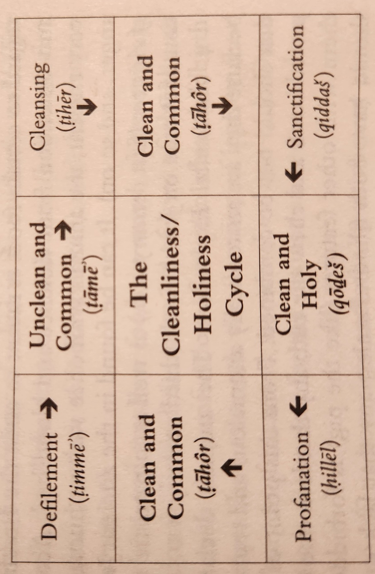
- A holy thing may never be unclean, nor an unclean thing holy.
- An unclean thing will defile a clean thing and desecrate a holy thing – render common.

Gradations of Holiness and Cleanness– certain precincts (like the Tabernacle courts) require stricter standards of cleanliness than others. Only certain “Holy” people can enter certain areas – see the Holy of Holies in the Temple, which is restricted to the High Priest.

Lev 11: 1-47
Clean vs unclean animals – Kosher foods, meaning “to be suitable.” Why does God restrict the Israelites – especially from certain animals like pigs and shellfish?
Noah after the flood was allowed to eat any kind of animal, “every moving thing that lives” – with a stipulation being that they shall not eat the flesh with the blood (Gen 9: 3-4).

- Hygienic Explanation: animals declared “unclean” are bad for human health and prohibited by God to ensure well-being of Israelites. Pork = trichinosis and Shellfish = filter feeders that concentrate environmental toxins in their tissues.
- Aesthetic Explanation: animals declared “unclean” are prohibited because they are repugnant to human beings (such as animals that “creep” and “swarm”) and therefore unworthy for consumption.
- Ethical Explanation: curbing of appetites with certain foods is meant to assist Israelites in growing in self-control and abstention from violence and bloodshed. In this ancient view, the animals symbolize various human passions (such as lust, envy, anger…).
- Anatomical Explanation: the animals declared “unclean” are forbidden because they are anatomically anomalous and represent the mixing of categories that should not be combined. Mammals should have parted hoofs and chew the cud; any that lack one of these (e.g. shellfish) are forbidden. This is a more modern view.
- Liturgical Explanation: Animals declared “unclean” were associated with the gentiles, their pagan culture and religion. Thus, this declaration would help to create social distance between Israel and foreign pagan nations, so that they might be set apart – “holy.” This view would help Israel avoid Idols and was supported by St. Thomas Aquinas.

Religious De-Egyptization – God commands that the gods or animals sacred to the gods of Egypt be sacrificed by Israel– cows, goats.

Clean vs unclean is more about cultic worship than about morality
Focuses on “abnormality” or contact with death or some loss of life.

- Childbirth: loss of blood, in which is “the life” (Lev 12: 1-8)
- Leprosy: loss of blood and body fluids in decaying flesh (Lev 14:1-56)
- Emission of Semen: loss of “seed”, containing life (Lev 15:1-12)
- Menstruation: loss of blood, in which is “the life” (Lev 15:19-30)
- Marital Intercourse: loss of “seed”, containing life (Lev 15:16-18)
- Contact with a corpse (Num 19:11-19)

Basic principle – Death has no place in the sanctuary of the Lord – Adam and Eve removed from the Sanctuary of the Garden because unclean

Things need to be clean to be in presence of God, before they can be made Holy.
Look at Sacraments – Baptism, Anointing of Sick, Eucharist – Older Form Book of Blessings

Pay attention!!!
These laws were not necessary before the Golden-Calf Incident, which shows that they were not absolutely necessary for a covenant relationship with God… thus, Jesus can fulfill them and the Old Law pass away, ushering in the New Law.

More laws are added in Numbers and Deuteronomy because of further rebellion, thus showing the Levitical Law to have a penitential aspect – they help to reorder and rehabilitate the Israelite Nation from a state of sin and rebellion to a state of Grace.

Levitical Law would have completely frustrated and excluded Egyptians and Canaanites – often their religious rituals expressly involved sexual activity/bestiality. Egyptians worshipped dead pharaohs and built chapels and temples over the tombs of pharaohs, which were religious pilgrimage sites.

The Day of Atonement (Leviticus 16)
In the middle of the Cleanliness Code (Lev 11-15) and the Holiness Code (Lev 17-25)
Contemporary – Yom Kippur – Day of Atonement vs Leviticus – Yom hakippurim – Day of Atonements
The word Kippur comes from kapar, which more closely means “purgation, purification, or expiation,” which brings about “atonement” – at- one – ment. In other words, reconciliation – between God and man, through the sprinkling of the blood of the sacrifices on the “mercy seat” of the ark of the Covenant.

Next to the Feast of Passover, the Day of Atonement gets the most detailed explanation in the Pentateuch – it was the definitive ritual that both cleansed and reconsecrated the priest, the people and the sanctuary.

Key elements of the Day of Atonement (Lev 16):

- The High Priest would enter into the innermost sanctum of the Tabernacle, known as the “Holy of Holies” – only done once a year on this feast day.
- The High Priest would offer a bull as a sin offering for himself, presumably as a kind of penance hearkening back to the worship of the Golden Calf by his sacerdotal ancestor, Aaron.
- The priest was to take two goats: (1) one goat “for the Lord” that would be sacrificed as a sin offering and (2) a second goat, “for Azazel”, that would not be sacrificed in the sanctuary but “sent away into the wilderness”.
- On this day, Aaron (and his successors) was commanded to enter the Tabernacle “in the cloud” of incense, “make atonement” for the people, and then symbolically communicate the sins of the people to the scapegoat by laying hands on its head so that it might “bear all their iniquities” (Lev 16:22).
- In preparation for such an awesome and solemn occasion, the people were to “afflict” themselves through fasting, penance, and abstention from sexual relations. Indeed, in the whole Mosaic law, the Day of Atonement is the only day on which fasting is required of the people of Israel. It is the Most Solemn day of the Israelite Liturgical Calendar.

The Holiness Code and Liturgical Calendar (Lev 17-26)
Prior to the grant of the covenant at Mount sinai, God promised that obedience to the covenant would result in Israel becoming a “kingdom of priests” and “holy nation” (Ex 19). Every Israelite, therefore, was called to be “holy” – that is set apart from sin and uncleanness and set apart for the presence of God. – “Consecrate yourselves therefore, and be holy, for I am holy” (Lev 11:44).

Gradations of Holiness = to your state of life

This section is referred to as the Holiness Code because the word Holy – “qadosh” – is repeated some 85 times.

- Israel to maintain holiness by sacrifices (Lev 17) – prohibition against consuming blood – “the life is in the blood.”
- Avoid unholy sexual relations, which would defile the land. Incest, practices of the Canaanites, homosexuality, sexual activity during menstruation, etc.
- Practice holy actions, leave food for the poor or sojourner, provide just wages, and not keeping day wages “all night” (Lev 19)
- Avoid illicit activities such as augury, witchcraft, self-mutilation, and tattoos (Lev 19)

- Violations of any of these rules of holiness are subject to punishment, in the form of death penalty (for adultery, cursing mother or father, bestiality, and sodomy) or exclusion from the community (for incest) (Lev 20). These same standards are even stricter for priests, since they handle the holy things of the Lord directly (Lev 21-22).

At the heart of the Holiness Code is a systematic description of the ancient Israelite liturgical year (Lev 23). From the ancient Israelite perspective, the rhythm of the life of worship (which theologians will later call the “order of redemption”) moves in time with the rhythm of the cosmos (which is later called the “order of creation”).
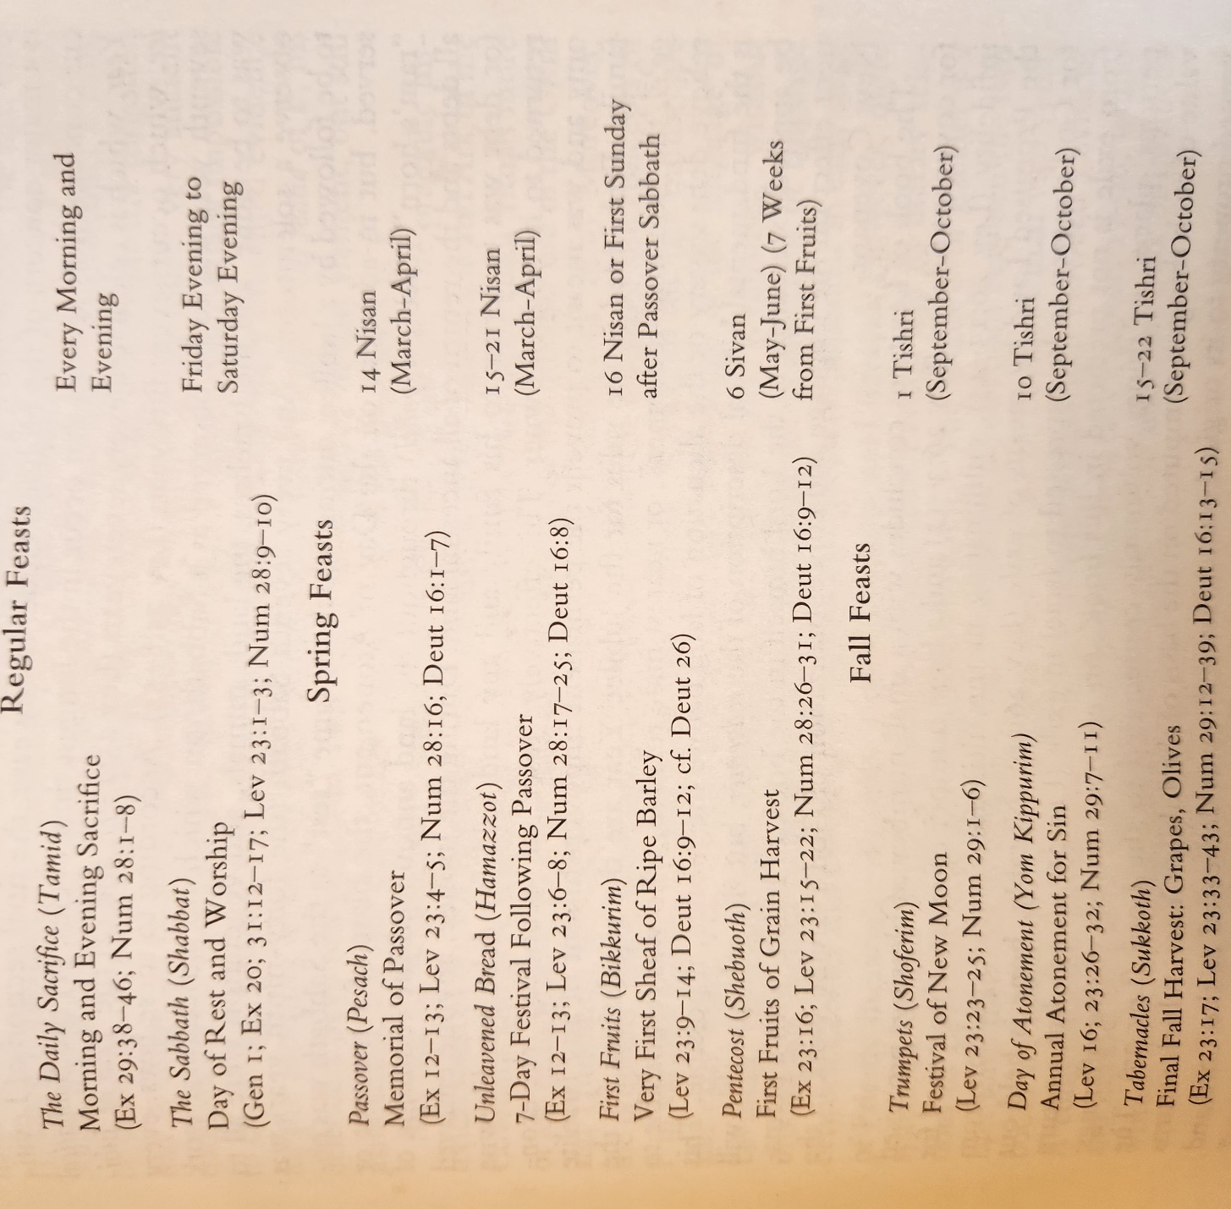

The Sabbatical year – every 7th year was to be observed as a Sabbath, on which no agricultural work was to be done, and the Israelites, the land, animals, and vegetation were all to observe a solemn rest.

The Jubilee year – every seventh Sabbatical year (49yr ) was to be followed by a year of Jubilee, during which the same rest was observed, but in addition, on the Day of Atonement, the blast of a trumpet or “ram’s horn” throughout the land announced the remission of all debts and the return of all ancestral land. During the Jubilee, anyone enslaved for debt was to return to his family and any land sold for debt was likewise returned to its original owner. It was a “reset”/”Reboot” of the economy and protected against the permanent impoverishment of any Israelite family.

“the kinsman-redeemer” – nearest male relative, who was responsible to relive debt slavery or the alienation of land before the Jubilee, if possible.

The Book concludes with a list of blessings and curses of the covenant. The ultimate curse is the expulsion from the Promised land by means of exile (Lev 26:39). Notably, hope is held out for God’s mercy to be expressed to Israel in exile (Lev 26: 44-45), but a return from exile is not predicted in this book.

An epilogue covers votive offerings: persons, places, or things voluntarily consecrated to the Lord (Lev 27). Such things are returned to the original owner during Jubilee, even if it was dedicated to the Lord and the sanctuary.

