Overview of the Book of Deuteronomy

Where have we been?
Freedom from Pharoah (Exodus), Covenant at Sinai with Golden Calf Apostasy (Exodus), Stricter Ritual Laws of Sacrifice and Living (Leviticus), Census of the People at Sinai before Leaving for Promised land (Numbers), Rebellion and Apostasy of 2nd Generation at Beth-Peor (Latter Numbers), the 2nd Generation prepares to enter the Promised Land (End of Numbers/Deuteronomy).

Exodus = drawing out of the Israelites from Egypt to worship their God
Leviticus = a sacred constitution established to keep Israel in proper worship
Numbers = amendments to the constitution as Israel continues to wander and rebel
Deuteronomy = a call to the 2nd Generation to keep the Covenant with God made at Sinai

“Deuteronomy” derives from a Greek word that means “Second Law”

“Second Law” is an apt title for the book, since it repeats the Ten Commandments (Deut 5:6-21) and presents itself as “another covenant” law in addition to the one God made with Israel at Sinai (Deut 29:1).

The Hebrew title of the book means “these are the words” or just “words.” This title is fitting because it conveys the sense of Deuteronomy as the parting speech of Moses, addressed to the 2nd generation of Israelites on the plains of Moab just before his death (Deut 1:1-2).

Deuteronomy is a very important and cited part of the Canon of Sacred Scripture. Only Genesis, the Psalms, and Isaiah of the Old Testament can rival Deuteronomy’s theological significance. The Psalms and Isaiah in some ways are dependent upon Deuteronomy.

The Dead Sea Scrolls and Deuteronomy – more copies found than any other biblical book except the Psalms.

In the New Testament, Deuteronomy is third after the Psalms and Isiah in the number of quotations and allusions – Deuteronomy is called the “linchpin” of the Old Testament – linking as hinge between the Pentateuch/Torah and the Historical Books.

Deuteronomy’s implications can be seen and understood in the books of history, prophets, and wisdom literature.

Deuteronomy recounts the final and definitive form of God’s covenant with Israel through Moses – after Moses, the covenant outlined in Deuteronomy is the theological and political “constitution” of Israel for the rest of the nation’s history, even if it was seldomly or never fully implemented.

Structure of Deuteronomy
Ch. 1 – 11: Moses’ opening Speech/Sermon

1 – 3: The Story Thus Far
- Recap of events
- To institute gratefulness and humility from the outset

4 – 11: A Call to Faithfulness
- the heart of this section is the Shema “Listen, O Israel, the Lord our God, the Lord alone, and you shall love the Lord your God with all your heart, all your soul, and all your might.”

- Listen = “Hear and respond,” in other words, obey.

- Love = “Emotion and decision,” in other words, devotion.

- Israel by following these laws are to be a beacon (Kingdom of Priests – Ex 19) of God’s Wisdom and Justice.

- The Lord Alone/”The Lord is One,” Israel is to worship only one god, the true God.

- The Promised Land has many tribes with many gods/goddess and false beliefs and immoral practices.

Ch. 12 – 26: Laws for Israel’s Entrance into the Promised Land

12 – 16a: Israel’s Worship
- To have one central temple for the one God.

- Worshipping God is linked to the care for the poor (anawim).

  - Set aside 1/10th of income yearly to be given to the temple. Another 1/10th of income every three years was to be given to the poor.

16b – 18: Israel’s Leaders placed under the authority of the Law (Elders, Priests, and Kings)
- God will send Prophets to apply the Law to these leaders (Israel’s leaders are to be subordinated to the Law and the Prophets)

- Kings in foreign nations were subordinate to no one, thought of as gods and lawmakers themselves

- So, God allowed for a King?

- Solomon’s Failure of Kingship contrasted to Deuteronomy (Many wives, many horses, keep the copy of the Law on a scroll and have it at all times, must read the scroll every day)

19 – 26: Civil Laws (Marriage, Family, and Business) and Social Justice/Legal System (Protection of Widows, Orphans and Foreigners/Immigrants)
- Concluded with more laws pertaining to Worship – showing a correlation between Justice and Worship (It is Right and Just…)

Tips for Reading the Laws of Deuteronomy
- Remember the laws are the terms of the Sinai Covenant to Ancient Israel.
- Don’t Compare them with modern laws, but with the laws of ancient neighbors (Code of Hammurabi/Assyrian Laws).
- Discern the core principle principles underlying the law. (See 1 Corinthians 9:9)

Did Moses plagiarize from the Code of Hammurabi?
Areas of Similarity:
Justice (Partial). Given that the image of God is in all men, and given that the law of God is inscribed on the hearts of men, it comes as no surprise that some of the laws in The Code are just.
Civil order. If a people would apply The Codes of Hammurabi and Moses, each offers a recipe for civil order.
The Lex Talionis, or “the principle that a person who has injured another person is similarly injured in retribution.” There’s lots of eye-for-an-eye type language in The Code, which also pops up in Moses, too.

*Jesus’ injunction “Turn the other cheek”

Areas of Difference:
Sanctity of human life. The Code of Hammurabi represents a lower view of human life than Moses. For instance, in The Code of Hammurabi, the consequence for theft is to repay ten- to thirty-fold. If that’s not possible, the thief is executed. That’s never the case in Moses.
Favoring the privileged vs. protecting the oppressed. Protection of the oppressed is near to God’s heart; not so much with Hammurabi. Many of Hammurabi’s laws favor the free and wealthy.
Justice. Though some of The Code of Hammurabi is just, much of it is eminently unjust. There is no injustice at all in the law of Moses.
Mercy. The notion of mercy is exceedingly rare in Hammurabi, but appears with regularity in Moses.
The focus of the laws. The vast majority of The Code of Hammurabi concerns money, property, and business transactions. While these are addressed in Moses, the focus on moral laws, loving and honoring God and taking care of man’s relationship to God are strong emphases in Moses.
Expanded and Applied Decalogue
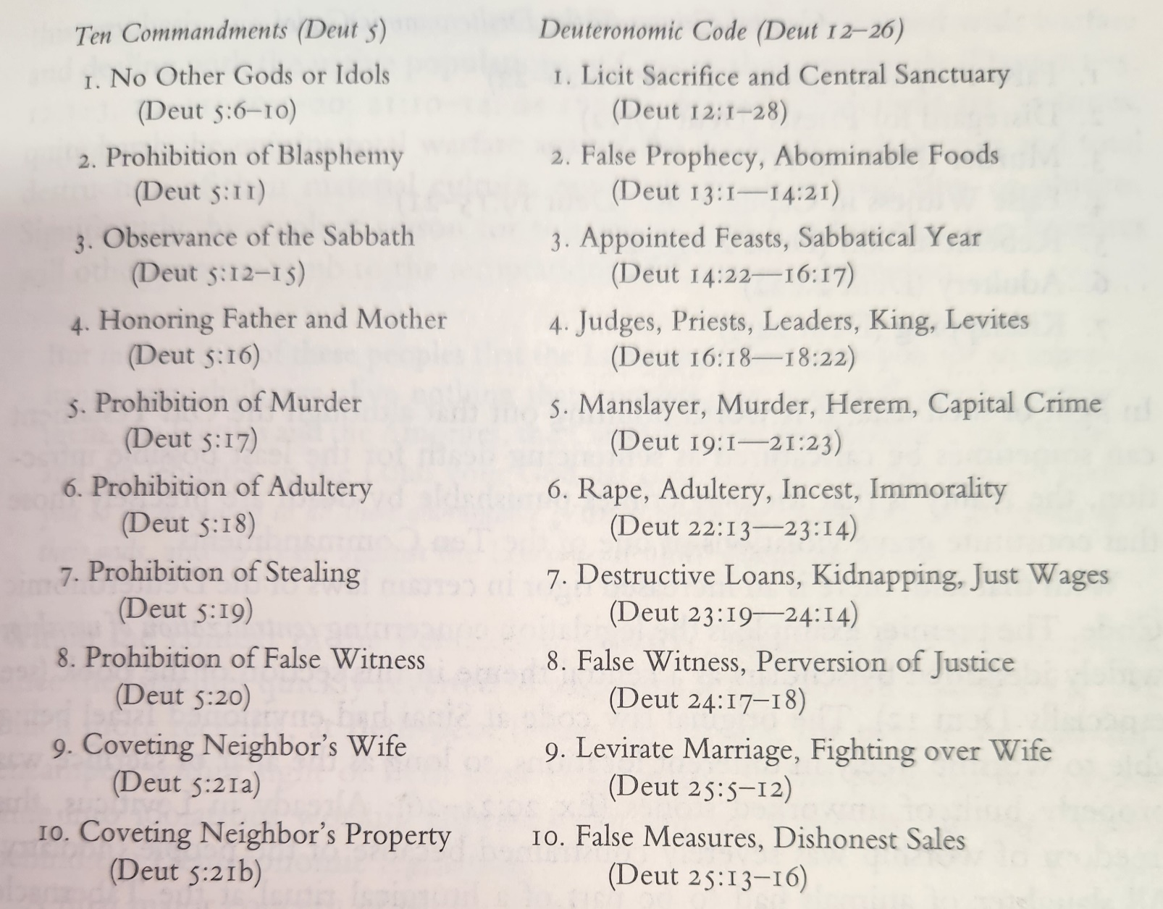

Ch. 27 – 34: Moses’ Final Speech/Sermon and Death

27 – 30: Warning and Ultimatum to the People
- Moses provides a ritual for the solemnization of the covenant, not to be done until entering the Promised Land
  - Joshua to write the law on stones at the top of Mount Ebal and then celebrate a ritual sacrifice (Deut 27:5-7)
  - Half the Tribes are to ascend Mt. Gerizim “to bless”, and half of the Mount Ebal “for the curse” (between these mountains was Shechem the original capital city of Israel for conquest).

- Listen and Obey = Divine Blessing

- Don’t Listen and Rebel = Famine, Plague, Devastation, and Exile

*Punishment vs Consequence (Law of Gravity example)

- Moses forces a decision “Today I set before you, Life or Death, blessing or curse, goodness or evil… so choose life, by loving the Lord your God an listening to Him” (Deut 30:15-20).

- Moses makes note that he knows the people will rebel eventually and fall into exile.

- Moses with hope says “[but one day…] The Lord your God will circumcise your hearts and the hearts of your descendants, so that you may love him with all your heart and with all your soul, and live” (Deut 30:6; cf. Deut 10:6).

- Prophets Jeremiah and Ezekiel preach about a “new heart.”

*Jesus (Not from without… but from within defiles [cf. Mk 7:20-23]
- The Fall in the Garden
- Proper Desire
- Sacred Heart

31 – 34: Moses’ Last Words and Death

32: Poem of Warning
- Moses reminds the Israelites by way of a song of their misdeeds, a “I told you so”
- Perpetuates his memory into the next generation, so that the Israelites might remember the covenant

33: Poem of Blessing over the Israelites by Tribe
- Reminiscent of Jacob’s Blessing over his sons at the end of Genesis (49)
- Jacob = Father of Israel the Family; Moses = Father of Israel the Nation

34: Moses climbs Mt. Nebo and sees the Promised Land before his Death
- Joshua is filled with the Spirit of wisdom because Moses laid hands upon him, so Joshua is the leader of the Israelites.
- “Since then, no prophet has risen in Israel like Moses, whom the Lord knew face to face, who did all those signs and wonders the Lord sent him to do in Egypt” (Deut 34:10).

Historical Controversy and Scholarship

- From the Book of Kings, during the reign of King Josiah after evil King Manasseh (2 Kings 21)

- The High Priest Hilkiah finds a Scroll in the walls of the Temple that contains the “Book of the Law”

- After hearing from the “book,” King Josiah is moved to repentance and immediately institutes sweeping religious reforms, including the destruction of all sanctuaries other than the Jerusalem Temple (2 Kings 22:11 – 23:28).

- Two Theories: (1) the “book” was composed by Josiah and “found” giving him the ability to destroy other worship sites and make the Davidic Kingship centralized and rooted in Jerusalem. (2) The “book” was composed of older material and was simply promulgated at the time of Josiah.

- Seemingly would be the book of Deuteronomy:
  - Centralize worship
  - Passover in Jerusalem alone
  - Elimination of mediums and the occult
  - Conformity of the king’s rule to the Book of the Law

Unresolved Questions of the Torah
- When will the descendent of the woman come to defeat evil? (Genesis 3)

- How is God going to rescue the world through Abraham’s Family? (Genesis 12)

- How can a holy God be reconciled to rebellious people? (Exodus-Numbers)

- How will God transform the hearts of His people? (Deuteronomy 30)

