Overview of the Book of Numbers
The Book of Numbers is only slightly less neglected than Leviticus among modern Christians.

The Title “Numbers,” does not denote an interesting story at first glance – the name “Numbers,” (Greek Arithmoi) refers to the two numberings of the 1st and 2nd generations in the Wilderness (Num 1 & 26).

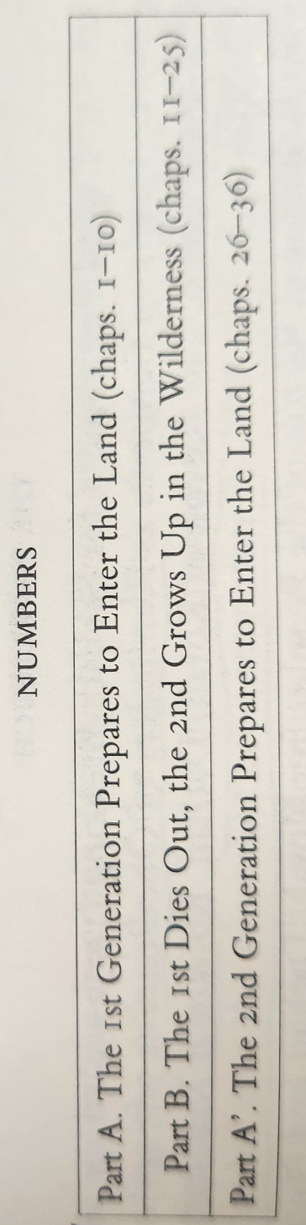

The Hebrew name for the book is more accurate to the content, Bamidbar – “In the Wilderness” – this is a proper name because it refers to the geographic and spiritual location of Israel throughout most of the Narrative.

Pay attention throughout Numbers to the complaining/grumbling/murmuring of the Israelites against God, which leads to their rebelling or striving against the Lord and His legitimate leader – Moses. (Should remind us of another book… the Exodus).

Exodus = a drawing out of the Israelites from Egypt to worship their God
Leviticus = a sacred constitution established to keep Israel in proper worship
Numbers = amendments to the constitution as Israel continues to wander and rebel

The laws in Numbers have an ad hoc, circumstantial character… in other words, someone or something breaks the constitutional law, and another law must be enacted in order to restore order. The laws/amendments of Numbers are not necessarily logical and successive.

Numbers sets the stage for Deuteronomy, giving the reader, the necessary info about the geographic and moral condition of the people of Israel when they arrive at the “plains of Moab beyond the Jordan at Jericho” (Num 22:1), at which Moses begins the book of Deuteronomy with an extended homily and renewal of the covenant (Deut 1:5).

The Census (Num 1)

Optimism begins the book
The Sin of the Golden Calf has been adjudicated and now Israel looks forward and is a numerous people – the large number indicates a fulfillment of the creational and patriarchal blessing (think back to the Creation story and story of Abraham).

Who has the right to call a Census?
- God
- Indicates a battle, which the King is to defer in faith to God
- Problematic if a king does it by himself and not through a Divine Command… indicates Pride or Bloodlust as well as Greed (Taxation)
1 Chronicles 21:1-3:
“Satan rose up against Israel and caused David to take a census of the people of Israel. So David said to Joab and the commanders of the army, “Take a census of all the people of Israel—from Beersheba in the south to Dan in the north—and bring me a report so I may know how many there are.” But Joab replied, “May the Lord increase the number of his people a hundred times over! But why, my lord the king, do you want to do this? Are they not all your servants? Why must you cause Israel to sin?””
Where is there a census in the New Testament???

The War Camp of Israel and the Levites (Num 2 – 4)

Not a random arrangement, but an arrangement of an ancient war camp.

Although the great number of Israelites is a sign of optimism in the conquest of the Promised land, the attention paid to the Levites is a reminder of the Golden Calf Incident.

In the Center is the Tabernacle with four groups of three tribes each surrounding it from the east, south, west, and north.

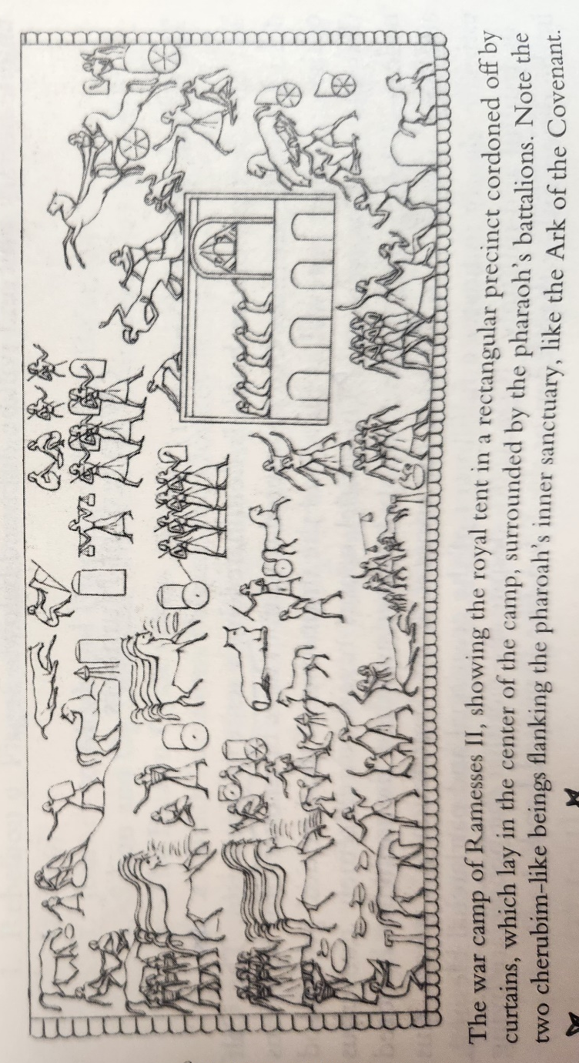

Mediation and “Buffering” because of Sin – between the 12 tribes of Israel and the Tabernacle Mose, priests and the Levites. The Levites are a defensive barrier to God’s holiness and incursion from the “lay” tribes.

The Levites act in a “diaconal” role in which they are secondary clergy the assist the priests and Moses with the extensive manual labor involved in the sacrificial liturgy (Leviticus 4:47). In other words, not all the clergy are the same, but have particular roles… tension about this will arise later in the Book of Numbers.

Careful census of the Levites contrasted with the Israelite 1st Born = an intentional sacral substitution of the Levites for the 1st born of each tribe. Originally, the 1st born had the privilege of the priesthood, but was lost through disobedience and sin.

Younger triumphing over the older theme foretold in Genesis (particularly in Reuben)… the other 11 tribes after the Golden Calf Incident are “laicized,” the tribes other than the Levites no longer fully participate in the call to be a royal priesthood.

In Catholicism, both/and, restores royal priesthood to laity, but still has a priesthood of mediation (Holy Orders).

Confession, the Suspected Adulteress, and Blessings (Numbers 5-6)

Acts of confession are outlined as well and restitution of moral offenses and uncleanliness. The ideas of “oral confession” and “penance” are indispensable. Full restitution is considered plus 20% more than the value of what was taken or stolen.

The Law for testing a suspected adulteress has deep narrative significance. Think of Israel and God’s exclusive relationship.

Nazirite Vow, a way of being set apart, being holy.

Provision for the priests to bless the people in the name of the Lord, an act that communicates God’s presence and holiness to the people… why do we ask for blessings of priests today?

Further Preparation for Departure (Numbers 7-10)

Significantly, the departure of Israel from Mount Sinai is marked by the celebration of Passover. The glory cloud is lifted from the Tabernacle and silver trumpets are blown by the priests to give Israel the signal.

Israel sets off for the Promised Land in battle array. (Allusion to the Priest’s Vesture at Mass; a new Exodus).

The First Three Rebellions in the Wilderness (Numbers 11-12)

Optimism is lost and a spirit of murmuring enters the scene. A reoccurrence of the original Exodus.

Initial rebellion results in a plague of Fire at Taberah (Num 11:1-3) … foreshadowing Hell fire and Eternal Rebellion???

People complain about the Manna, they even begin to despise the heavenly gift: “there is nothing at all but this manna to look at” (Num 11:16). So, they are given quail/flesh to eat.

Moses complains about the unruly people and his inability to handle the unruly mob. God gives Moses seventy/seventy-two spirit-inspired under prophets. (Ordination Prayer)

Some of the Israelites die of a plague that comes from the eating of the quail.

Dissent also breaks out among the leaders of Israel. There is jealousy and resentment toward Moses’ position as the head leader. (Moses as a Papal Figure).

Moses’ family betrayal and Cushite Wife incident
- False gods
- Polygamy?
- Racism

The Great Revolt of the Spies’ Report and Aftermath (Num 13-14)

Central Crux of the plot of the book of Numbers

12 spies chosen to investigate the Promised Land and give reports on if the Israelites could overtake the enemies therein

Majority vs Minority Report
10 spies say to go back to Egypt
2 spies say to immediately conquer the land (Joshua of Ephraim and Caleb of Judah)

People adopt the majority report and try to stone Moses so that they might have a new leader who would take them back to Egypt.

The Golden Calf Incident again
- God threatens punishment of the people and offers Moses the opportunity to become a “great nation” through his own progeny.
- Moses intercedes for Israel and tells God of his Mercy promised to the people
- The Lord pardons, but there is a qualification...

“none of the men who have seen my glory and my signs which I wrought in Egypt and in the wilderness… shall see the land which I swore to give to their fathers… but your little ones, who you said would become a prey, I will bring in, and they shall know the land which you have despised.” (Num 14)

The Exodus generation will die out and those born in the Wilderness will be the ones to experience the Promised Land.
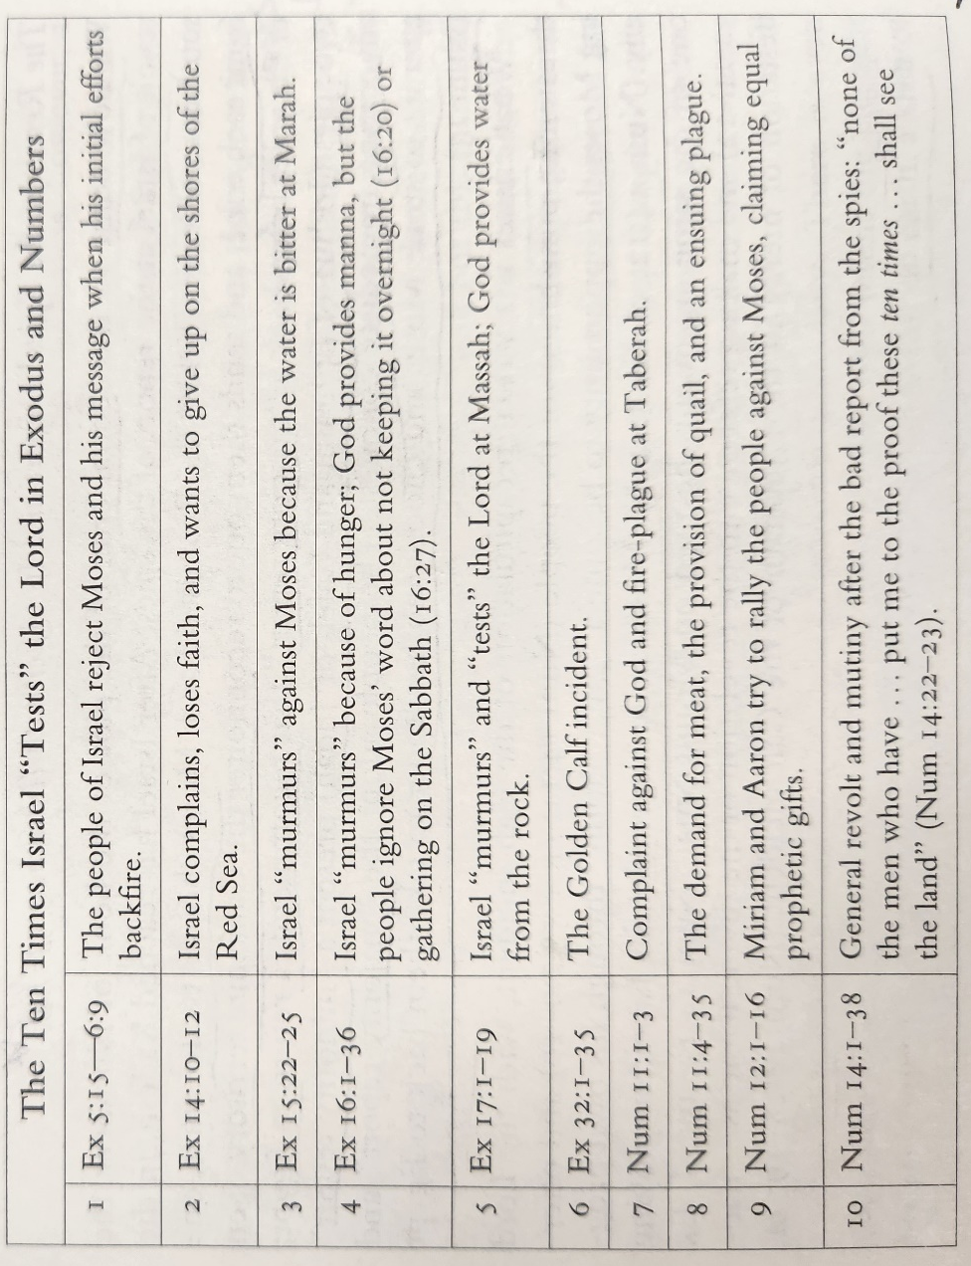

God gives the Israelites who rebel, what they want…

Further disobedience, the Israelites try to take the Promised Land by themselves, and disaster ensues… a type of Babel?

Laws for Unintentional and Intentional Grave Sins (Numbers 15)

Increase of requirements for sacrificial offerings – cereal offerings of fine flour mixed with oil and a libation of wine are now required along with the standard offering… in other words more expensive. (Foreshadowing of Eucharist?)

Inadvertent Grave Sins and Deliberate Grave Sins

Tassels worn by Jewish people as Sacramentals

Korah’s Rebellion and Aftermath (Numbers 16-17)

A usurpation of the “Priesthood of all Believers,” not to eradicate the priesthood, but to claim it and wield the priesthood for themselves.

Use of the Political and Historical to usurp the Priesthood from Aaron

God supernaturally intervenes… Aaron’s staff is the only staff to bloom of the leaders… the people still grumble.

Laws for Levites, Priests, and Corpse Impurity (Numbers 18 – 19)

Laws and responsibilities distinguish the priests from the Levites

God provides a ritual for “Holy water,” that will cleanse the Israelites from corpse defilement. The water has the power to cleanse connected to the mysterious sacrifice of the “red heifer,” which can be then be sprinkled using a branch of hyssop upon the Tabernacle, the furnishings, and the persons who may have become unclean through contact with a corpse (Num 19:14-19).

Jesus and the Red Heifer

The Waters of Meribah and the Fiery Serpents (Numbers 20 – 21)

Moses’ Sin – acting without God’s command – striking the rock to bring forth water, when God only instructed to speak to the rock.

Punishment of Moses – he will not enter the Promised Land – even God’s leader could not overcome a lack of Faith and Personal Sin

Sin is wholly contagious and continues to destroy (Noah and the Flood)

Aaron dies

Fiery Serpents and Idol Worship

The Balaam Cycle (Numbers 22-24)

Theme of Hopefulness through the prophet Balaam – he tries to curse Israel but blesses them instead.

Messianic Prophecy of Balaam

God protecting Israel from threats they are not aware of

The Apostasy of Israel at Beth-Peor (Numbers 25)

Idolatry and Sexual Misconduct in the plains of Moab, another rehashing of the Golden Calf incident – a sign of sin in the Second Generation

Phineas’ zeal halts the sinful corruption and saves the Second Generation from complete destruction

Beth-peor in the Plains of Moab, is the place were Israel will remain for the remainder of the Pentateuch.

The Second Generation Prepares to Enter the Land (Numbers 26-36)

Another Census is taken – none of the men of the 1st Generation remain.

The sonless Zelophehad and the continuation of the “name” as a sign of Israelite hope

Israel as the suspected unfaithful wife, proven by the test in the wilderness

Is the Second Generation any better than the First?
- Moses’ Comparisons
- Lack of Rigor and spirit of compromise

