Exodus can be thought of as the “son, Israel” being in a relationship with God.
1. Call
2. Covenant
3. Communion

Exodus 16-18 : The Miracles on the Way to Mt. Sinai
God’s gracious provision despite Israel’s complaints.
God woos his people even more by “wonders,” as they travel through the desert to Mt. Sinai
Covenant of Father to Son, but Bridegroom to Bride
Woos = in many ways, God is a lover that speaks to his bride (Israel), He shows his great Love for her, but she is not moved by his Love because of her own attachment to sin. (Bridal Imagery is very popular through the Old Testament – see Hosea and Song of Songs as examples. Jesus uses similar imagery when he speaks of Himself and the Church (New Israel)).

Particular Miracles to pay attention to:
- The Transformation of bitter water at Marah (“Bitterness”) to sweet water when Moses throws the wood of a “tree” into the water (Ex 15:22-25).
- Provision of “Bread” (Manna) and “flesh” (quail) from heaven when Israel cries out for food (Ex 16)
- The flow of water from the rock at Meribah (“contention”) or Massah (“testing”) (Ex 17:1-7).
- The Miraculous overthrow of the Amalekites through the intercession of Moses and his outstretched arms (Ex 17:8-16).

Miracles are actually rare in the Hebrew Scriptures – mostly restricted to the time period of Moses and Elijah and Elisha.

*** What really is Manna?
- The word Manna means “What is it?”
- Congealed Sap of a desert shrub?
- Emission of an insect living in the desert?
- A natural occurrence?
Problems with purely natural occurrence: the text states it as supernatural and did trees or insects keep the Sabbath?

Mount Sinai and the 10 Commandments (Exodus 19-24)
Ch. 19 and 24 bracket the other chapters (20-23) by describing covenant rituals and the Divine Theophany

Ch. 20 – 23 are about the laws that govern the covenant relationship.

Review – What is a Covenant? (Think back to the Abrahamic Covenant)

Exodus 19:3-6
“And Moses went up to God, and the Lord called to him out of the mountain, saying, “Thus you shall say to the house of Jacob, and tell the sons of Israel: You have seen what I did to the Egyptians, and how I bore you on eagles’ wings and brought you to myself. Now therefore, if you will obey my voice and keep my covenant, you shall be my own possession among all peoples; for all the earth is mine, and you shall be to me a kingdom of priests and a holy nation. These are the words which you shall speak to the children of Israel.”
Notice –
- God meets Moses on a Mountain
- God making mention of his providential care for Israel (not only this generation)
- God’s special covenant and respect for our free will
- Contingent on obedience
- Promise of being a kingdom of Priests (Royal Priesthood) and a holy nation
Who served as Priests before the Levites?
- Exodus mentions Israelite “priests” before the Golden Calf Incident who performed priestly duties prior to the giving of the 10 Commandments
- Priesthood of the First Born – of the Patriarchs
- Adam’s Royal Priesthood in the Garden (“till” and “keep” / “guard” and “rule”)
- Priesthood corrupted by Sin and Damaged by the Fall
- God’s intervention to Abram seeking to pour out priestly blessing upon him and his descendants (great nationhood, great royal name, and universal blessing to all) – progeny, legacy, and prosperity).
- Israel is to be a New Adam and the Fulfillment of the Abrahamic Covenant… but they mess it up (See Golden Calf Incident Ex 32 and later faults of the Nation of Israel). Only a partial fulfillment of the blessings promised by God are poured out upon Israel.
- Thus, the New Israel (The Church) inherits the covenant long promised through Christ and fulfills it.

Giving of the 10 Commandments (Exodus 20)
*** Covenant and Law are not synonymous terms – difference? (Covenant is prior then comes Law – Covenant is Familial and Law is what governs the relationship to keep order).

Law in this sense consists of stipulations that uphold the proper carrying out of the covenant.

Why do Catholics have a different set of commandments than many other Christian denominations?
- The 10 Commandments are written down in Exodus and Deuteronomy
- The Counting in Judaism and most of Protestantism separates the commandment against other gods (Ex 20:3) from the prohibition of idols (Ex 20:4) to form two commandments. Likewise, they combine the prohibitions against coveting wives and property into one (Ex 20:17), forming one final commandment.
- From Saint Augustine, Catholics and Lutherans count the commandments as derived from Deuteronomy 5:7-21.
- Prohibition of gods and idolatry as one commandment – and separates lust and avarice of a neighbor’s wife and goods. In Hebrew two separate words are used in Deuteronomy for coveting/desiring.

The Commandments set Israel apart from other Nations – makes them “holy”

Two Tablets – How are they divided?
Tablet 1:
- Sanctity of God
- Sanctity of the Divine Name
- Sanctity of Time
Tablet 2:
- Sanctity of Paternity and Maternity
- Sanctity of Life
- Sanctity of Marriage
- Sanctity of Private Property
- Sanctity of Speech/The Truth
- Sanctity of Another’s Spouse
- Sanctity of Another’s Property

Notice how breaking of a higher commandment will have a trickle down effect upon the “orderliness” of human society.
Only two commandments are never described as punishable by death, which are they?
- Coveting begins in heart not only evident in action

The Covenant Code and the Liturgy at Mount Sinai (Exodus 21-24)

The Code of Hammurabi and the Covenant Code – similarities and differences

Statutory Law vs Common Law
Statutory Law systems function by the strict application of the written code
Common Law systems allow freedom to the individual judge, who consults unwritten tradition as well as written codes and judicial precedents to derive principles to apply to a particular case.

Moses did not intend the Covenant Code to be exhaustive but rather a code that establishes principles to be applied to future cases and problems.

Thus, God does not communicate his will exhaustively by Scripture alone (sola scriptura) – the written word is always delivered to a society that already has a tradition and religious authorities (e.g., Moses, the Elders, and judges) to interpret and apply that “word” or “law” properly.

Theophanic Covenant Banquet –
Sacrifice followed by Meal in which God appears and reveals himself to his people – in Exodus and O.T. – At the Last Supper – In the Mass – In Eternity.

The Tabernacle of Moses (Exodus 25-31)
“the Tent of Meeting”

Much attention is paid to the materials and form of the Tabernacle – hyper-focused on proper Worship and Symbolic meaning.

Divinely Revealed – “you are to worship me in this manner” – Moses takes instructions and makes the construction occur.
The Tabernacle is to be a portable Mount Sinai. What has occurred on Sinai between God and his people is to be connected with and represented in the liturgy of the Tabernacle as Israel travels to the Promised Land.

Mt. Sinai = Tabernacle of Moses (Parallels)
“Feet”/ Throne of God (Ex. 24:10) = Ark of the Covenant (Footstool) (Ex. 25: 10-22)
Heavenly Banquet – Eat and Drink = Golden Table of the Bread (and Wine) of the Presence
Cloud of Fire = Golden Lampstand of Fire
Blood Sacrifices on the Altar at the Foot of Mount Sinai = Bronze Altar of Sacrifices in the Outer Court
Washing with Water before Coming to Mount Sinai = Bronze Laver of Water, in the Outer Court

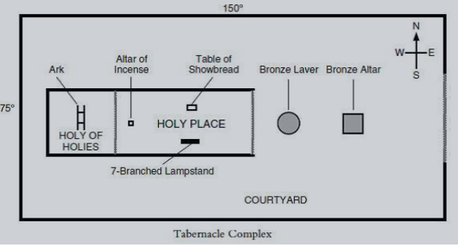

Movement from Bronze to God = being rarefied as we come closer to God (Correlation to Purgatory)

The Golden Calf Incident and the Broken Tablets (Exodus 32 – 34)
Impatience among the Israelites as Moses is away for 40 Days and 40 Nights – so they take things into their own hands. (Lack of Belief in God’s Providence – Infantilism under Moses).

Aaron – curiously passive or intimidated constructs a golden calf for the Israelites – identified with golden-bull calf, Apis, from Egyptian Pantheistic religion or Canaanite deity, El. (Danger of Modern Spiritualism).
They imitate sacrifice and a meal and then rise up “to play” – non-marital sexual activity that accompanied “worship” of pagan deities, many of whom were associated with virility and fertility.
Idolatry = Spiritual Adultery
Flesh over the Spirit
Carnal over Eternal

The curses of the Covenant are to be executed upon Israel for the breech of the new covenant – not just arbitrary or vengeful, but proper enforcement.

Moses offers his own life for the people – intercedes on their behalf to spare them from just punishment (Think of Abraham and Sodom and Gomorrah). Moses reminds God of His covenant with Abraham of a great nation and many descendants sworn after the Akedah.

Smashing of Tablets shows God’s righteous anger and the breaking of the Covenant by Israel.

Chaotic scene at foot of Mt. Sinai – a holy place defiled by orgies and the riotous spirit of Israel.

Moses rallies one group around him, the Levites, who execute the leaders of the rebellion. By this act, the Levites “ordain” themselves “for the service of the Lord” (Ex 32:29). They gain a priestly status by defending and enforcing the covenant of Sinai, enforcing the first commandment.

In Exodus 34:10-28, laws are added to the covenant – a renewed Sinai Covenant – that are stricter and points to the Book of Leviticus – a book of additional legislation to keep Israel away from Apostasy.

Moses returns to God, up the Mountain – he is shown a greater level of intimacy than before – he sees his glory and his face is radiant. The Golden Calf incident has allowed Moses to rise above pure intercessory prayer to Self-Sacrificial mediation. Mysteriously, Moses would never gain such a state unless there was the sin of the people (O Felix Culpa).

Sinaitic Covenant gives way to the Levitical Covenant after the Golden Calf
From direct covenant (Firstborn son acted as priests of all twelve tribes) to triangulated relationship with an intercessor (Moses – made a covenant with you and Israel) – (Levitical Priests).

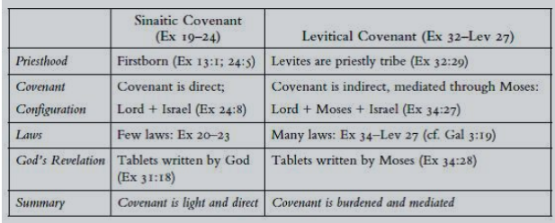

Forbidden Fruit of Adam is the Golden Calf to Israel. Both Adam and Aaron try to pass blame and both are “first-born sons” who broke filial covenants with God almost immediately after those covenant were made.

Construction of the Tabernacle (Exodus 35-40)

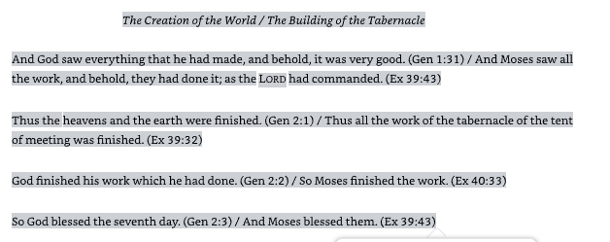
A sign of God’s mercy that he still has them build the Tabernacle after the rebellion – simply, He will remain with them even in the midst of their sinfulness.
Parallels between Creation and Creation of Tabernacle – A Place of Creation, Redeemed World, A New Eden (Resurface in Israel’s Temple)

Sacraments foreshadowed in Exodus???
Sacraments as Miracles

