The Book of Kings (1 and 2 Kings)
The Central Focus = The Rise and Fall of the Davidic Kingship

Two Basic Outlines: (Whole and Divided/Political and Prophetical)

A. One Kingdom under the Son of David: Solomon (1 Kings 1-11)
B. Two Kingdoms, Israel and Judah (1 Kings 12 – 2 Kings 17)
A’. One Kingdom under the Son of David: Judah Alone (2 Kings 18-25)

- The Divided Monarchy before the Great Prophets (1 Kings 12-16)
- The Divided Monarchy during Elijah’s Ministry (1 Kings 17 – 2 Kings 1)
- The Transition from Elijah to Elisha (2 Kings 2)
B’. The Divided Monarchy during Elisha’s Ministry (2 Kings 3-13)
A’. The Divided Monarchy after the Great Prophets (2 Kings 14-17)

The Prophetic ministries of Elijah and Elisha provide a sense of hope during the otherwise dismal account of the decline of Israel and Judah.

The Literary Pattern/Characteristic of the Books of Kings:
Solemn and stately, official and authoritative, occasionally dry and annalistic.

Royal, Prophetic and Priestly Themes
Three anointed roles – Priest, Prophet, and King
- Royal Theme: dominant theme – how will the covenant that God made with David be upheld in such upheaval?

- Prophetic Theme: dominant theme in the center of the book, prophets take center stage from the kings during the heyday of the northern kingdom. The literary crux of the work is the ascension(assumption) of Elijah and the succession of Elisha (2 Kings 2), which reminds the reader that God has other officers and ways of working with his people besides the kings and their royal administration. Other prophets exist other than Elijah and Elisha as well. The unexpected and gratuitous rise of these prophets “like Moses” (cf. Deut 18:15) is another cause for hope.

- Priestly theme: focus on the Jerusalem Temple, the place of priestly ministry, and traces the story of God’s sanctuary from its glorious construction and dedication under Solomon (1 Kings 5-8) to its destruction and dismantling by the Babylonians (2 Kings 25). The theme of the central sanctuary is prominent throughout: the northern kings, beginning with Jeroboam’s construction of two – golden calves (1 Kings 12), are always criticized for promoting the illicit sanctuaries. The southern kings likewise are judged based on their attitude toward the central sanctuary and their toleration or prohibition of illicit sanctuaries. The best kings (Solomon in his youth, Hezekiah, Josiah) are temple (re)builders and liturgical reformers.

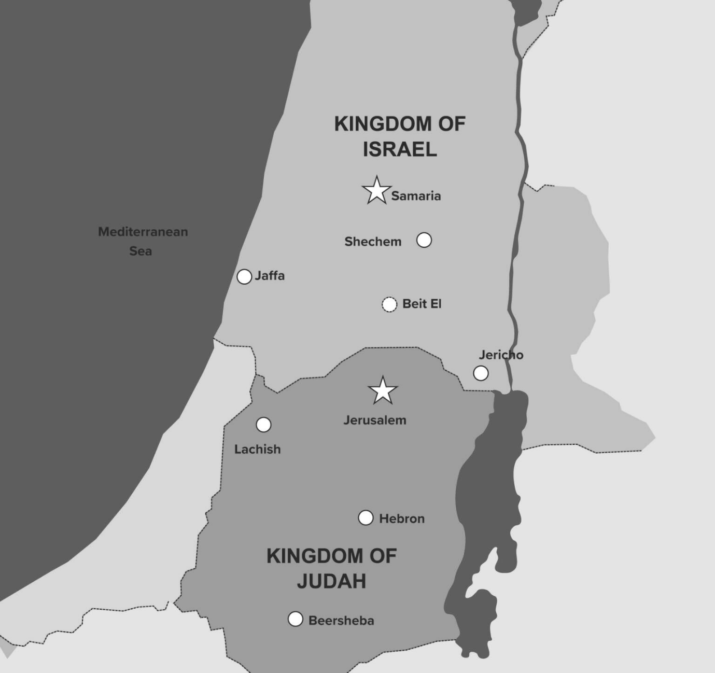

The Glory Days of Israel (1 Kings 11) – the Rise and Fall of King Solomon
- All 12 tribes are united under 1King – the only time in the history of Israel
- Building of the Temple in Jerusalem, a living witness of God’s Love for Israel
- Peace, but still Political – Adonijah (David’s Eldest Son) and the politicking of David, Bathsheba and Nathan – Solomon supported by David and Zadok and Nathan – riding a mule to Gihon Spring and anointed King – promise of God to David, that his “seed” would be king over 12 tribes of Israel
- Solomon’s Wisdom – asks for understanding – “to discern between good and evil” – God blesses Solomon with Wisdom and Riches – No other King will match his Glory – Story of the Two Harlots and the Child (1 Kings 3:16-28)
- Transformation of Israel into an International Kingdom (Empire) by Solomon:
“Judah and Israel were as many as the sand by the sea; they ate and drank and were happy. Solomon ruled over all the kingdoms from the Euphra′tes to the land of the Philistines and to the border of Egypt; they brought tribute and served Solomon all the days of his life.” (1 Kings 4:20-21)
- Israel seems to be living out the characteristics of being a “kingdom of priests” (Ex 19:5-6) and a light to the surrounding nations (Is 60:3)
- The Glory of Israel is greatest in the First Temple of Jerusalem (1 Kings 6-8) – both Israelites and Gentiles help to build the Temple – unlike the Mosaic Covenant, whose Tabernacle was built only by Jews, the Temple under the Davidic Covenant is universally built – the Temple is similar yet greater than the Tabernacle – the Temple of Solomon as a Microcosmos
- Solomon, like David, acts as Priest and King… offering sacrifice, leading a long prayer of seven petitions, and blessing the people (1 Kings 8:22-66)
- The Ark of the Covenant comes into the Temple and a week long feast at the expense of King Solomon – the Visit of Queen of Sheba (Modern day Yemen) and Solomon’s breaking of the Law of Moses for Kings… the 3 P’s… Pleasure, Possessions, and Pride/Power

The Two Kingdoms under Rehoboam and Jeroboam (1 Kings 12 – 16:28)
- After the Death of Solomon, the Kingdom splits… The Northern Kingdom – “Israel” (10 Tribes) and the Southern Kingdom – “Judah” (2 Tribes, Benjamin and Judah)
- Think of the American Civil War – Union and Confederacy – and National Identity, but sides considering themselves to be “True Americans”
- Bride Imagery and Divorce/Schism – Davidic Kingship
- Meet at Shechem (a neutral site) to discuss Rehoboam as rightful son and heir of Solomon as King of Northern Tribes along with Southern Tribes. The Northerners complain of the taxes and forced labor – “lighten the hard service of your father and his heavy yoke upon us” (1 Kings 12:6-24) – Rehoboam refuses and the Northern Tribes rebel and choose Jeroboam (Solomon’s former officer of forced labor) as their new king
- Rehoboam refuses to start a civil war and thus Jeroboam is given the necessary time and resources to begin his kingdom in the northern territories. Jeroboam makes a grave mistake in erecting two sites of false idol worship to keep his people from going to Jerusalem for worship – at Tel-Dan and Bethel – a Northern and Southern location of worship within the Northern Tribes territory
- “sin of Jeroboam” = idol worship at these sites and betrayal of the Mosaic and Levitical Laws
- Jeroboam is a New Aaron and a New Saul – not only schism in the political but in the cultic
- The Fate of the Northern Tribes is sealed in their turning away from God… a prophecy of a coming king, Josiah, will destroy the idolatrous shrines. Ahijah the prophet curses the line of Jeroboam and so his lineage is extinguished and to be replaced with a different royal blood line. The northern kingdom will continue to be chaotic, each king continues to be overthrown by usurpers that rise to power – the “household of Omri” remains the longest, but their stability does not bring holiness, but the evilest king, King Ahab
- The capital of the North continues to be changed by subsequent kings, a sign of instability and illegitimacy
- Meanwhile, in the Southern Kingdom, things are not great… Rehoboam continues the faults of his father and expands illicit shrines and cultic prostitution (1 Kings 14:21-24) - * Note: although the author of the Book of Kings is clearly from the Southern Kingdom, he does not whitewash the reality of sin in his own territory
- Some kings are better than others, but none rise to the height of holiness to deliver the People of God from their sins

The Prophet Elijah (1 Kings 16:29 – 2 Kings 2)
- The bulk of Elijah’s ministry happens during King Ahab’s reign in the Northern Kingdom
- Ahab continues the evil of his predecessors but also marries a pagan woman of Phoenicia/Tyre – Jezebel – she has King Ahab worship her god, Baal, as well as Baal’s consort, Asherah (1 Kings 16:31-33)
- King Ahab’s conflict with Elijah – “Troubler of Israel”
- The Scandal of the Vineyard of Naboth and the prophecy of the dogs fulfilled (1 Kings 21)
- Elijah = Yahweh is my God… not much introduction was given for Elijah as such an important prophet… well known already to the reader, as well as Elijah being a nobody
- Elijah’s Characteristics –
- Miracle Worker – controlling weather, the widow of Zarephath, 1st act of raising the dead (1 Kings 17:8-24)… laying upon vs the spoken word to raise the dead
- Cultic Reformer – “liturgical showdown” (1 Kings 18) – prophet acting as a priest in time of political division – Mass conversion to Yahweh
- New Moses – Sinai/Horeb, is commissioned to anoint a new generation of leadership for Israel and Syria. Elijah takes Elisha as a disciple (a new Joshua)
- Ascending into Heaven – Elijah’s final miracle to part the waters of the Jordan, but instead of going into the Promised Land, he ascends into heaven by a chariot of fire and horses in a whirlwind (2 Kings 2:11-12)

The Prophet Elisha (2 Kings 3-14)
- Elisha = “My God saves!”
- Elisha’s Characteristics:
- Serves as prophet under many kings instead of a continuous king
- Greatest Miracle Worker of O.T. – “inherit a double share of Elijah’s spirit” – not meaning twice as great as Elijah, but a double inheritance of the sons/disciples of Elijah, like a firstborn son – 13 recorded miracles by Elisha
- An ordinary death – but his bones will later give healing

The Fall of Israel: The Assyrian Exile (2 Kings 15-17)
- After Elisha’s death, Northern Israel gets worse and worse Kings (in the southern Kingdom, King Uzziah rules righteously for 50 years… 792 – 740 BC)
- 722 BC is a date to remember – the Assyrian Exile of the 10 Northern Tribes of Israel
- The deportation of the 10 Tribes happens in two key stages:
- Initial deportation at the time of King Pekah beginning in “Galilee” and “all the land of Naphtali” (2 Kings 15:29)
- Later deportation carrying off the reminder of the tribes and scattering them in Gentile territories (2 Kings 17:6)
- The Assyrian exile was not only political, but liturgical
- The Problem of Assyria was brought on by the civil battles of the Northern and Southern kingdoms of Israel… Israel with Syria were allies and so Judah and Assyria were allies
- Diaspora and intermarrying, pagans/gentiles in the northern kingdom - Samaritans
Breakdown of Events:
Initial Assyrian Influence:
Judah, under King Ahaz, initially sought Assyrian support against Syria and Israel, becoming a vassal state and paying tribute to the Assyrian Empire.
Babylonian Rebellion:
Babylon rebelled against Assyrian rule in 705 BC and attempted to persuade Judah to join their revolt, but Judah, under King Hezekiah, refused and trusted in God for deliverance.
Assyrian Invasion of Judah:
In 701 BC, Assyria, under King Sennacherib, invaded Judah, but God intervened and delivered Judah from the Assyrian armies.
Babylonian Rise to Power:
Babylon eventually rose to power and, along with the Medes, defeated the last Assyrian king, Ashur-uballit II, in 609 BC, effectively ending the Neo-Assyrian Empire.
Babylonian Captivity of Judah:
In 597 BC, Babylonians, under King Nebuchadnezzar, invaded Judah and destroyed it, leading to the Babylonian captivity of the Jewish people.
Judah's Later Fate:
Jerusalem was not destroyed until 587 BC, and Judah remained under Babylonian rule until 538 BC when it was captured by the Persians.

Important Foreign Kings (Assyrian and Babylonian):
Shalmaneser V:
He initially besieged Samaria, the capital of the Northern Kingdom of Israel, after King Hoshea rebelled.
Sargon II:
Succeeded Shalmaneser V and completed the conquest of Samaria, taking the inhabitants captive and deporting them to Assyria.
Tiglath-Pileser III:
While not directly involved in the exile of the Israelites, Tiglath-Pileser III, who preceded Shalmaneser V, also played a role in the history of the Northern Kingdom of Israel, annexing the territory of the tribes of Reuben, Gad and Manasseh in Gilead.
Sennacherib:
Sennacherib, successor to Sargon II, attacked Judah during the reign of King Hezekiah and destroyed most of her principal cities.
Nebuchadnezzar II:
It was the Neo-Babylonian king Nebuchadnezzar II who later conquered Judah and exiled the Judean elites to Babylon, destroying Solomon's Temple in 586 BCE.

The Fall of Judah: The Babylonian Exile (2 Kings 18-25)
- Remaining chapters bear witness to the “struggle for the soul” of the Southern Kingdom of Judah in the form of both extremely righteous and extremely wicked rulers (Reactionary Politic)
- King Hezekiah (729-686 BC) – leads moral and political resurgence… in contrast to his father, Ahaz, Hezekiah purges Judah of paganism… however, Hezekiah’s challenge to the Assyrians after the fall of Israel leaves Judah less politically stable
- Hezekiah pays tribute to Assyria… is healed by the prophet Isaiah… but a prophecy of destruction is foretold about Judah by the Babylonians
- Manasseh the son of King Hezekiah, undoes the work of his father – Manasseh is remembered as the evilest of all the kings of Judah and he reigns for a long time – 55 years… his son is Amon (named after an Egyptian sun-god)… Amon is assassinated and a good king returns - Josiah
- King Josiah’s reign marks a religious high-point in Judah… the famous finding of the Deuteronomic Law in the Temple walls by his High Priest, Hilkiah
- Passover is a national celebration hosted in Jerusalem… all shrines are destroyed… the Levitical Law is followed… but too little too late
- Josiah goes to battle against the Pharoah of Egypt and is slain in battle at Megiddo… eventually the Pharoah creates a vassal king in Jerusalem and then Egypt is overtaken by the Babylonian empire, which has regional dominance… thus leading to the Babylonian exile
- The Books of Kings end in a slight mention of hope… the exiled King of Judah, Jehoiachin is released from prison and allowed to eat at the Babylonian king’s royal table, and is given a living allowance from the crown for the rest of his life

